SEG Awards Level 2

Motor Vehicle Studies

Underpinning Knowledge Evidence Record

F/601/5515 Knowledge of Routine Motorcycle Maintenance

Learners Name
SEG Awards Registration Number
Centre Name
Assessor 1 Name
Assessor 2 Name

DECLARATION OF AUTHENTICITY

This declaration must be completed and signed by the learner and countersigned by the tutor / assessor and covers all evidence submitted for moderation.

Learner Name
Unique Learner Number (ULN) |  | SEG  Learner Reg. ID
Qualification Title
Centre Name

Learner statement of authenticity

Before signing please read the guidance below.

I confirm, that the attached assignment / portfolio is all my own work and does not include any work completed by anyone other than myself. I have completed the assignment / portfolio in accordance with SEG Awards’ instructions and within the time limits set by my centre.

Signature |  | Date

Centre confirmation of authenticity

On behalf of …………………………………….(insert centre name), I confirm that the above mentioned learner, to the best of my knowledge, is the sole author of the completed assignment / portfolio attached, and the assessments have been completed under the required conditions.

Signed |  | Date
Name
Title

Guidance for Learners

You have been asked to sign this Declaration of Authenticity and place it at the front of your portfolio or course work assessment. It confirms that the work you have submitted for assessment is your own and that you have not copied it from someone else or allowed another learner to copy it from you.

When preparing any course work it is good practice to undertake research using information from published sources. If you quote directly from these sources then this must be indicated in your work by using quotation marks and referencing the document from which the quotation was taken. You must then comment in your own words on any ideas expressed.

Assessors, internal verifiers and SEG Awards’ external moderators and verifiers are subject specialists who can spot the use of published materials that may be passed as your own words or ideas.
If you do copy words from a published source and do not indicate their reference you will be committing plagiarism. This is considered a form of cheating and may result in your assessment being declared void.

Contents

Task No | Title | Assessment Criteria
1 | Motorcycle inspection | 1.1, 1.3, 1.8, 1.9.
2 | Conforming to manufacturers’ specification | 1.3, 1.4, 1.5, 1.6, 1.7
3 | Importance of maintenance | 2.1, 2.2

Task 1 – Motorcycle inspection | Assessment Criteria 1.1, 1.3, 1.8, 1.9.

Use the diagram below to identify any pre-existing damage and state how you would report this
Motorcycle Details |  | Motorcycle Condition Report
Make____________________________  Model____________________________  Registration/VIN No._____________________________  Colour___________________________ |  | 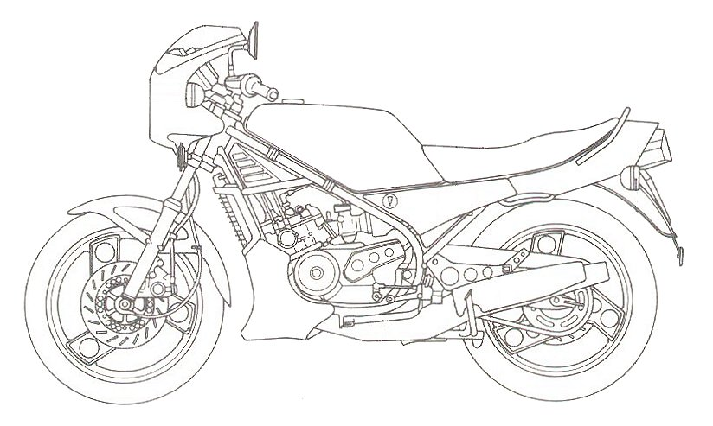
Identify components to be removed and re-fitted during routine maintenance | Sources of Information Used
 | Workshop  Manual |  | Autodata | Internet | Other  (State)
1.
2.
3.
4.
5.
6.
7.
8.
Explain how to conduct a scheduled routine motorcycle inspection

Task 2 – Conforming to manufacturers’ specification | Assessment Criteria 1.3, 1.4, 1.5, 1.6, 1.7

Identify the assessment methods you would use to ensure the vehicle conforms to the manufacturers’ specifications
Engine
Component | Method of inspection
1.
2.
3.
4.
5.
Chassis/frame (steering, suspension, brakes, wheels and tyres)
Component | Method of inspection
1.
2.
3.
4.
5.
6.
7.
8.
Transmission and driveline
Component | Method of inspection
1.
2.
3.
4.
Electrical and electronic
Component | Method of inspection
1.
2.
3.
4.
5.

Task 3 – Importance of maintenance | Assessment Criteria 2.1, 2.2

What are the advantages of having a motorcycle correctly maintained and kept in a roadworthy and legal condition?
Why is it important to have a motorcycle maintained while it is under manufacturers’ warranty?

Unless otherwise stated e.g. for some entry level qualifications, learners can work together but should identify sections which are their own work.

